**All Analyzing Experimental Data with One-Way ANOVA & Bar Graphs**

*Over the next two weeks in lab we will learn to analyze data using ANOVAs in JASP and practice making bar graphs with error bars in Excel. We will also analyze the data from the memory study, which will form the basis of lab report #2.*

|  |  |  |  |  |  |  |  |  |  |  |  |  |  |  |  |  |  |  |  |  |  |  |  |  |  |  |  |  |  |  |  |  |  |  |  |  |
| --- | --- | --- | --- | --- | --- | --- | --- | --- | --- | --- | --- | --- | --- | --- | --- | --- | --- | --- | --- | --- | --- | --- | --- | --- | --- | --- | --- | --- | --- | --- | --- | --- | --- | --- | --- | --- |
| **1. Practice One-Way (between-subjects) ANOVA**  Let’s compare the means of several independent groups of participants that vary on a single independent variable. This is known as a ‘one-way’ ANOVA because the groups vary only in one way.  **Here is an example of the kind of research question you might have:** Does the number of distracting conversations in a room have a significant effect on the number of speech errors (e.g. calling a friend or loved one by the wrong name) people make when talking to a partner? To answer this question, a researcher randomly assigned participants to one of four groups: No distractions, 1 distracting conversation, 2 distracting conversations, or 3 distracting conversations. Then participants engaged in a conversation with a partner while the experimenter recorded the number of speech errors made.  The data (the number of errors made by each subject in each condition) are:   |  |  |  |  | | --- | --- | --- | --- | | **NO DISTRACT** | **ONE DISTRACTION** | **TWO DISTRACT** | **THREE DISTRACT** | | 3 | 5 | 5 | 7 | | 2 | 6 | 4 | 8 | | 1 | 7 | 6 | 9 | | 3 | 4 | 5 | 10 | | 2 | 6 | 7 | 12 | | 4 | 7 | 4 | 15 | | 2 | 6 | 6 | 9 | | 3 | 6 | 4 | 8 |   ***I: Create (and save) a .csv file using Excel containing these data***  **A.**  Your spreadsheet should have two columns: one for “**Condition**” (your independent variable, which has four levels) and one for “**Speech Errors**” (your dependent variable, which is a continuous variable).  When creating the spreadsheet, keep in mind that each score above was taken from participants in different groups. In other words, each score represents a *different* participant. Also remember that in Excel and JASP, each row represents *one* participant. Therefore, the above data must be entered in a single column (each score from each participant must appear on separate rows), resulting in a total 32 rows of data when the dataset is complete (plus one row for headings).  ***II: Run your analyses in JASP and report the results***  **A:** Load your .csv file into JASP. Make sure “Speech Errors” is being treated as a continuous variable (i.e., that it is represented with the ruler icon)!  **B:** Click on the “ANOVA” tab, then “ANOVA”  **C:** Move “Speech Errors” to the DV box, and “Condition” to the Fixed Factors box.  Macintosh HD:Users:stephenflusberg:Desktop:1.png  **D:** We want to make sure we conduct post hoc tests so we can tell which groups were significantly different from another. To do so, click on the “Post Hoc Tests” tab below the main analysis boxes, move “Condition” to the box on the right, and select which Post Hoc Test type you would like to conduct (I usually use Bonferroni, but you are welcome to use Tukey or Scheffé if you like).  Macintosh HD:Users:stephenflusberg:Desktop:2.png  **E:** We also want to make sure we compute descriptive statistics and a measure of effect size. To do so, click the “Additional Options” tab below where you found the Post Hoc Test tab, and then under “Display” click “Descriptive Statistics” and “Estimates of effect size” (we will use eta squared, the default option here).  Macintosh HD:Users:stephenflusberg:Desktop:3.png |
|  |

|  |  |  |  |  |
| --- | --- | --- | --- | --- |
| 1. | **Do distractions increase the amount of speech errors?** | | | |
|  | a. State the Null and Alternative Hypotheses: | | | |
|  | *H0*: | All means will be the same | | |
|  | *HA*: | At least one mean will be different | | |
|  | b. What variable/s are you including in your analysis? | | | |
|  | Variable/s: | Distractions, speech errors | | |
|  |  | | | |
|  | c. What test should you use? (be specific!) | | | One way ANOVA |
|  | d. Please copy the information from your output: ANOVA  | *ANOVA - speech_errors* | | | | | | | | | | | | | | | --- | --- | --- | --- | --- | --- | --- | --- | --- | --- | --- | --- | --- | --- | | Cases | | Sum of Squares | | df | | Mean Square | | F | | p | | η² | | | distractions |  | 52.594 |  | 3 |  | 17.531 |  | 16.029 |  | < .001 |  | 0.632 |  | | Residuals |  | 30.625 |  | 28 |  | 1.094 |  |  |  |  |  |  |  | |  | | | | | | | | | | | | | | | Note.  Type III Sum of Squares | | | | | | | | | | | | | |    Descriptives  | *Descriptives - speech_errors* | | | | | | | | | | | | | --- | --- | --- | --- | --- | --- | --- | --- | --- | --- | --- | --- | | distractions | | N | | Mean | | SD | | SE | | Coefficient of variation | | | 0 |  | 8 |  | 2.500 |  | 0.926 |  | 0.327 |  | 0.370 |  | | 1 |  | 8 |  | 5.875 |  | 0.991 |  | 0.350 |  | 0.169 |  | | 2 |  | 8 |  | 5.125 |  | 1.126 |  | 0.398 |  | 0.220 |  | | 3 |  | 8 |  | 5.125 |  | 1.126 |  | 0.398 |  | 0.220 |  | |  | | | | | | | | | | | |    Post Hoc TestsStandard (LSD)  | *Post Hoc Comparisons - distractions* | | | | | | | | | | | | | --- | --- | --- | --- | --- | --- | --- | --- | --- | --- | --- | --- | |  | |  | | Mean Difference | | SE | | t | | pbonf | | | 0 |  | 1 |  | -3.375 |  | 0.523 |  | -6.454 |  | < .001 | *** | |  |  | 2 |  | -2.625 |  | 0.523 |  | -5.020 |  | < .001 | *** | |  |  | 3 |  | -2.625 |  | 0.523 |  | -5.020 |  | < .001 | *** | | 1 |  | 2 |  | 0.750 |  | 0.523 |  | 1.434 |  | 0.975 |  | |  |  | 3 |  | 0.750 |  | 0.523 |  | 1.434 |  | 0.975 |  | | 2 |  | 3 |  | -4.441×10-16 |  | 0.523 |  | -8.493×10-16 |  | 1.000 |  | |  | | | | | | | | | | | | | *** p < .001 | | | | | | | | | | | | | Note.  P-value adjusted for comparing a family of 6 | | | | | | | | | | | | | | | |
|  | e. Report your results below in APA style sentences. | | | |
|  | We ran a one-way ANOVA to determine whether the quantity of distractions (0, 1, 2, 3) impacted the quantity of speech errors made. Analyses revealed a significant effect of distractions on the quantity of speech errors made, F(3)=16.029, p<0.001. Post-hoc comparisons using the Bonferroni correction indicated that speech errors were significantly fewer at 0 feet (M= 2.5, SD=0.926) than at 1 (M=5.875, SD=0.991), 2 (M=5.125, SD=1.126), or 3 feet (M=5.125, SD=1.126). Speech errors | | | |
|  | f. What is your decision regarding *H0*? | | Reject the null hypothesis  Fail to reject the null hypothesis | |

**F:** Now, report your results in the proper APA formatted manner. I’ll get you started a bit of a template, though you will have to complete it on your own (more help can be found in some of the lecture slides on complex designs). If there was a statistically significant F-test, then you will also need to report your post hoc results (Note: describe *p*-values for **all** post hoc results. You do not need to include other information from the post hoc tests (e.g. *t*-values)).

A one-way between subjects ANOVA was conducted to compare the effect of (state your IV here) on (state your DV here) under (state the number of levels here) conditions: (list conditions here). There was (a/no) significant effect of (the IV) on (the DV) in this analysis, *F*(df between groups [i.e., df for your IV], df within groups [i.e., df residual]) = _____, *p* = ______, η2 = ________. Post hoc comparisons using the __________ test indicated that the mean number of speech errors for the ________ condition (*M* = ______, *SD* = ______) was significantly different from the ________ condition (*M* = ____, *SD* = _____)....

A one-way between subjects ANOVA was conducted to compare the effect of distractions on the number of speech errors made under four conditions: zero, one, two, and three distractions. There was a significant effect of distractions on the number of speech errors made in this analysis, *F*= 16.029, *p* <0.001, η2 = 0.632. Post hoc comparisons using the Bonferroni correction indicated that the mean number of speech errors for the zero distraction condition (*M* =2.5 *SD* = 0.926) was significantly smaller than for the one distraction condition (*M* = 5.875, *SD* =0.991, p<0.001), two distraction condition (*M* =5.125, *SD* =1.126, p<0.001), and three distraction condition (*M* =5.125, *SD* =1.126, p<0.001). The mean number of speech errors for the one distraction condition, however, is not significantly different from the two distraction (p=0.975) and three distraction (p=0.975) conditions. The mean number of speech errors for the two distraction condition is not significantly different from the three distraction condition, with p=1.

**2. Creating a Graph of Your Results in Excel**

Note that the screenshots depicted below are NOT from this analysis so the variable names will not match those you need. The images are here to help guide you in terms of where to click or what formulas to use, or the overall “look” of a bar graph.

As you know, data visualization (e.g., graphs, charts) plays an important role in communicating (and understanding) data. Plus, making graphs is sort of fun. Therefore, for Lab Report #2 you are going to create a bar graph of your data using Excel.

1. Open up a NEW Excel sheet and set up the cells where you will input your data about the condition means from JASP (and calculate your error bar values) like so:

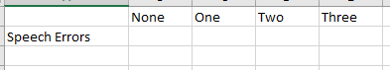

1. Next, refer to the descriptives you calculated in JASP and input the values for the mean number words remembered (and SD) for each of the conditions in this new spreadsheet in the appropriate place. For example, the selected cell above in blue is where you put the mean number of words remembered for those in the Words condition.
2. Once you have completed this, you should calculate the Standard Error of the Mean (SEM) for each condition. **You can actually calculate the Standard Errors using JASP now! Under the “additional options” tab (where you click to compute descriptives) in your JASP file, simply drag the “Condition” variable into the box on the right under the “marginal means” heading.**
3. Now it’s time to actually create the graph. Click to highlight the Condition Names and also the mean number of words you remembered. You do not need to highlight the actual words “Condition” or Mean Words Remembered” since you will manually add the proper headings later. Then click to the “chart” tab above and select “column” for graph type and then “clustered column”; Note that this will look different in the PC version of Excel than in the image below, and also note that the numbers I used below are made up and will NOT be the numbers you have calculated.

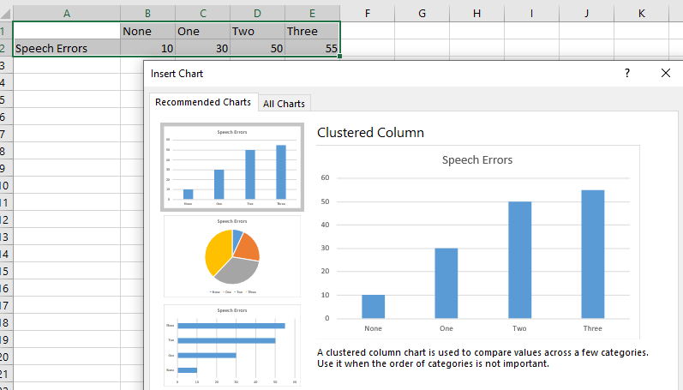

1. Now you should see a basic graph of the data, but an ugly one that is missing key elements. If you cannot get to this stage, you missed something above and should go through the steps again.

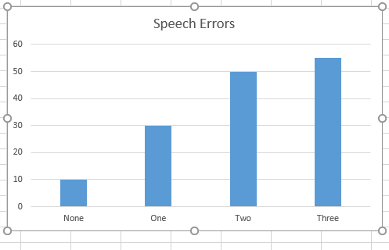

1. First, it’s time to make the graph look more professional. First, click and delete the thing that says “Series 1”. Next, double click on different elements of the graph (the bars, the numbers, the gridlines, the bars…) and adjust them to look better. Please increase the size of the font of all the words and delete the background gridlines. Also, change the color of the bars to something else. The way to learn how to manipulate graphs in Excel is to explore it on your own, so have some fun clicking around. If you can’t figure out how to do something, GOOGLE IT!
2. Next, you should add axis titles for the X and Y-axes so someone looking at your graph knows what’s actually being depicted. So, click “Design” and then “Add Chart Element” and then “Axis Titles” and create horizontal (X-axis) and vertical (Y-axis) titles.
   1. The X-axis should read “Distraction Condition” and the Y-axis should read “Number of Speech Errors”. Double click these titles to increase the font sizes. Note that you may have to click and drag to move them into the right spots, which also may require clicking and dragging to increase the size/dimensions of the graph itself.

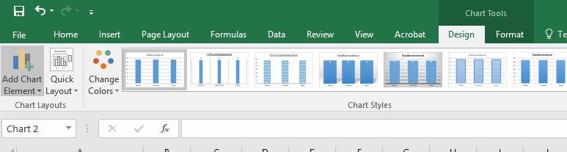

1. At this point your graph should look something like this (note that my numbers are made up so your numbers will be very different. Also, your color choice for the bars may be different). If your graph does not have all these elements, keep working on it!

Remember this is an example graph showing you formatting only.

1. Now it’s time to add the error bars to the graph, which uses the variability in our sample data to illustrate the amount of “error” we may have in our sample means in terms of their ability to estimate the population means we are interested in. Smaller error bars indicate less variability in our sample and/or that our sample was extremely large, which would suggest we have made a more precise measurement of the population means in our samples. Typically, people use either Standard Errors of the Means (SEMs) or 95% confidence intervals for their error bars. In this graph we will use SEMS, which you calculated earlier. First, in “Add Chart Element,” add error bars. Then, double click on one of the bars in the graph, then click on the “error bars” option on the right, click to “both” for how the bars should be displayed, then click “custom” for the error amount. For “end style” you can use no cap or a cap; that is up to personal preference.

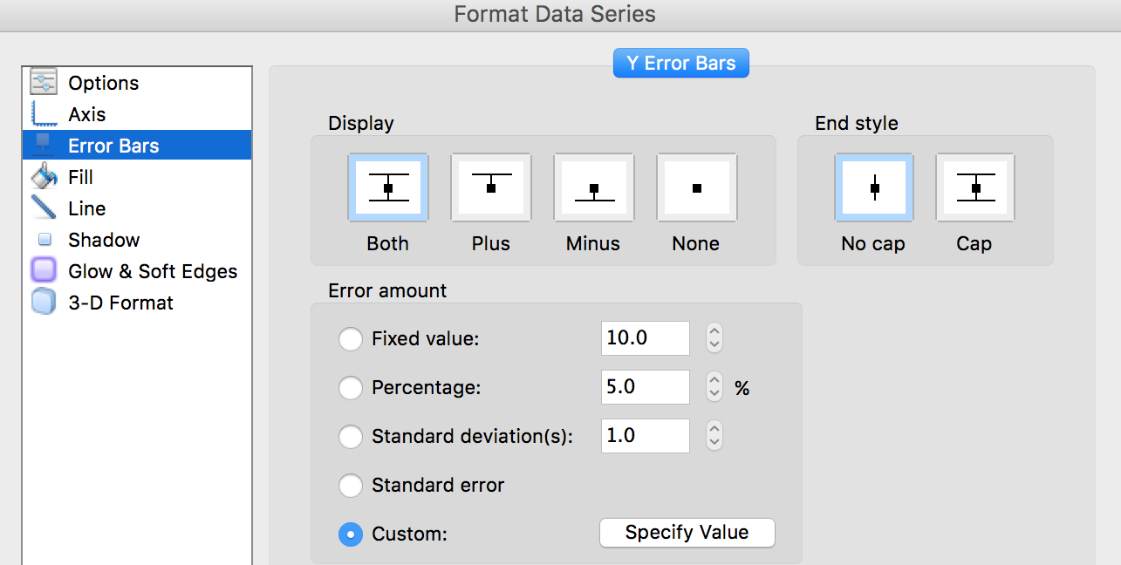

1. 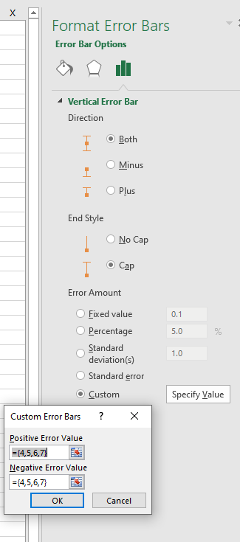Next click on “Specify Value”. Here, for both the positive and negative error value you will do the same thing; within the curly brackets {}, input the SEM you calculated for each condition, separated by commas. Then click OK. {In the example below the SEMs I made up SEMS of 4,5,6, & 7 for each of the conditions. We use the same values for the positive and error value to make the error bars symmetrical above and below the mean.
2. At this point your graph is almost complete and should look something like the graph below (except for the actual values, of course!). If there is something wrong, go back and keep working on it. Please include this graph in Lab Report 2, either in the results section or at the end of the document, with a **figure caption**. When you copy and paste the graph into Word, you should “paste special” and paste it as a PDF document. That way it will not maintain its link to your Excel file.

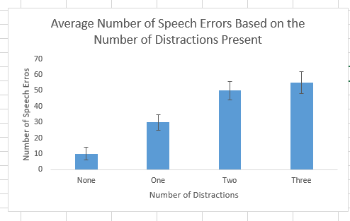

*Figure 1.* Table depicting the average amount of speech errors made across four levels of distraction.

Remember again this graph is showing you the formatting you want ONLY. The quantities shown on your graph will all be different.

1. After pasting it into your document, add a figure caption like the one above.

**Paste your graph (with figure caption) below:**

**3. Show what you know!**

**Analyzing the Disney Data using One-Way ANOVA.** Download Disney Data.csv from Moodle.

We have a datafile on Disney movies. Each movie’s RottenTomatoes.com score was recorded from both the audience and the critics. Each movie was also coded on a variety of features, including the theme of the movie. For example, each movie was coded as either being primarily about the hero combating a villain, the hero combating society, or the hero’s self-growth (a personal journey to overcome something within themselves).

For each research question, see if you can do the following:

a. Analyze the data

b. Write up the data in proper APA style

c. Make a bar graph in Excel to depict the results. Make sure to include error bars.

|  |  |  |  |  |
| --- | --- | --- | --- | --- |
| 3. | **Determine whether the movie’s theme predicts audience Rotten Tomatoes scores.** | | | |
|  | a. State the Null and Alternative Hypotheses: | | | |
|  | *H0*: |  | | |
|  | *HA*: |  | | |
|  | b. What variable/s are you including in your analysis? | | | |
|  | Variable/s: |  | | |
|  |  | | | |
|  | c. What test should you use? (be specific!) | | |  |
|  | d. Please copy the information from your output: | | | |
|  | e. Report your results below in APA style sentences. | | | |
|  |  | | | |
|  | f. What is your decision regarding *H0*? | | Reject the null hypothesis  Fail to reject the null hypothesis | |

**Copy and paste a bar graph (including standard error bars) of your results:**

|  |  |  |  |  |
| --- | --- | --- | --- | --- |
| 4. | **Does the protagonist’s gender affect critic Rotten Tomato scores?** | | | |
|  | a. State the Null and Alternative Hypotheses: | | | |
|  | *H0*: |  | | |
|  | *HA*: |  | | |
|  | b. What variable/s are you including in your analysis? | | | |
|  | Variable/s: |  | | |
|  |  | | | |
|  | c. What test should you use? (be specific!) | | |  |
|  | d. Please copy the information from your output: | | | |
|  | e. Report your results below in APA style sentences. | | | |
|  |  | | | |
|  | f. What is your decision regarding *H0*? | | Reject the null hypothesis  Fail to reject the null hypothesis | |

**Copy and paste a bar graph (including standard error bars) of your results.**

# 4. Understanding Interactions

*\*for all outcomes, assume any difference is a significant difference*

|  |  |  |  |  |
| --- | --- | --- | --- | --- |
| **Outcome 1:** |  |  | Size | |
|  |  |  | Small | Large |
|  | Type of Pet | Dogs | 4 | 6 |
|  |  | Cats | 3 | 6 |

|  |  |  |  |  |  |  |  |  |  |  |  |  |  |  |  |  |  |  |
| --- | --- | --- | --- | --- | --- | --- | --- | --- | --- | --- | --- | --- | --- | --- | --- | --- | --- | --- |
| 1. | What is the appropriate name of the design of this analysis? | | | | | | | | | | |  | | | | | | |
|  | | | | | | | | | | | | | | | | | | |
| 2. | What is Factor A? | | |  | | | | | | | | | | | | | | |
|  | What are the levels of Factor A? | | | | | | |  | | | | | | | | | | |
|  | What are the overall means for: | | | | | | | A1: |  | | | | A2: | | |  | | |
|  | Is there a main effect of Factor A? | | | | | | | ☐ No ☐ Yes | | | | | |  | | |  | |
|  | | | | | | | | | | | | | | | | | | |
| 3.. | What is Factor B? | | |  | | | | | | | | | | | | | | |
|  | What are the levels of Factor B? | | | | | | |  | | | | | | | | | | |
|  | What are the overall means for: | | | | | | | B1: |  | | | | B2: | | |  | | |
|  | Is there a main effect of Factor B? | | | | | | | ☐ No ☐ Yes | | | | | |  | | |  | |
|  | | | | | | | | | | | | | | | | | | |
| 4. | Graph the results:  *make sure to label everything appropriately!* | | | | DV mean scores |  | |  | | | | | | |  | | | **Dogs** |
| **7** | |
| **6** | | **Cats** |
| **5** | |
| **4** | |  |
| **3** | |
| **2** | |  |
| **1**- | |
|  |  | | |  | | | | _**Small___ __Large____** | | | | | | |  | | | |
|  | | | | | | | | | | | | | | | | | | |
| 5. | Is there an A X B interaction? | | | | | | | ☐ No ☐ Yes | | | | | |  | | |  | |
| **Outcome 2:** | |  |  | | | | Alcohol | | | |
|  | |  |  | | | | Beer | | | Wine |
|  | | Gender | Males | | | | 30 | | | 30 |
|  | |  | Females | | | | 20 | | | 40 |

|  |  |  |  |  |  |  |  |  |  |  |  |  |  |
| --- | --- | --- | --- | --- | --- | --- | --- | --- | --- | --- | --- | --- | --- |
| 1. | What is the appropriate name of the design of this analysis? | | | | | |  | | | | | | |
|  | | | | | | | | | | | | | |
| 2. | What is Factor A? |  | | | | | | | | | | | |
|  | What are the levels of Factor A? | | | |  | | | | | | | | |
|  | What are the overall means for: | | | | A1: |  | | A2: | | |  | | |
|  | Is there a main effect of Factor A? | | | | ☐ No ☐ Yes | | | |  | | |  | |
|  | | | | | | | | | | | | | |
| 3.. | What is Factor B? |  | | | | | | | | | | | |
|  | What are the levels of Factor B? | | | |  | | | | | | | | |
|  | What are the overall means for: | | | | B1: |  | | B2: | | |  | | |
|  | Is there a main effect of Factor B? | | | | ☐ No ☐ Yes | | | |  | | |  | |
|  | | | | | | | | | | | | | |
| 4. | Graph the results:  *make sure to label everything appropriately!* | | **DV mean scores** |  |  | | | | |  | | | **Male** |
| **40** |
|  | **Female** |
| **30** |
|  |  |
| **20** |
|  |  |
| **10-** |
|  |  |  | | | **__Beer____ ___Wine__** | | | | |  | | | |
|  | | | | | | | | | | | | | |
| 5. | Is there an A X B interaction? | | | | ☐ No ☐ Yes | | | |  | | |  | |

|  |  |  |  |  |  |  |
| --- | --- | --- | --- | --- | --- | --- |
| **Outcome 3:** |  |  | Medication | | | |
|  |  |  | Placebo | DrugA | DrugB | DrugC |
|  | Gender | Males | 4 | 2 | 3 | 1 |
|  |  | Females | 2 | 4 | 3 | 5 |

|  |  |  |  |  |  |  |  |  |  |  |  |  |  |
| --- | --- | --- | --- | --- | --- | --- | --- | --- | --- | --- | --- | --- | --- |
| 1. | What is the appropriate name of the design of this analysis? | | | | | |  | | | | | | |
|  | | | | | | | | | | | | | |
| 2. | What is Factor A? |  | | | | | | | | | | | |
|  | What are the levels of Factor A? | | | |  | | | | | | | | |
|  | What are the overall means for: | | | | A1: |  | | A2: | | |  | | |
|  | Is there a main effect of Factor A? | | | | ☐ No ☐ Yes | | | |  | | |  | |
|  | | | | | | | | | | | | | |
| 3.. | What is Factor B? |  | | | | | | | | | | | |
|  | What are the levels of Factor B? | | | |  | | | | | | | | |
|  | What are the overall means for: | | | | B1: |  | | B2: | | |  | | |
|  |  | | | | B3: |  | | B4: | | |  | | |
|  | Is there a main effect of Factor B? | | | | ☐ No ☐ Yes | | | |  | | |  | |
|  | | | | | | | | | | | | | |
| 4. | Graph the results:  *make sure to label everything appropriately!* | | DV mean scores |  |  | | | | |  | | | **Males** |
|  |
| **6** | Females |
| **5** |
| **4** |  |
| **3** |
| **2** |  |
| **1-** |
|  |  |  | | | **Placebo DrugA DrugB DrugC** | | | | |  | | | |
|  | | | | | | | | | | | | | |
| 5. | Is there an A X B interaction? | | | | ☐ No ☐ Yes | | | |  | | |  | |